

**Course Code: 1201-01**

**Date:**

**Created By:**

Dhara Savaliya(100648840, Tizita Habtemariam(100685214), & Vishwa Bhavsar(100678769)

**Group Name: Group 6**

**MErry RECREATION CENTRE**

Table of Contents Page No#

Introduction-------------------------------------------------------------------------------------------------1-4

Format of Tables-------------------------------------------------------------------------------------------4-13

Screenshots--------------------------------------------------------------------------------------------------14

(1) Relationship Diagram--------------------------------------------------------------------------------14

(2) Tables Structure and Datasheets-----------------------------------------------------------------14-22

(3) Queries Structure and Datasheet-----------------------------------------------------------------22-29

(4) Forms View---------------------------------------------------------------------------------------------30-31

(5) Reports View-------------------------------------------------------------------------------------------32-33

Project Rubrics----------------------------------------------------------------------------------------------34-35

APA References---------------------------------------------------------------------------------------------35-36

**Recreation Centre**

In the current era, sport is not only used for exercise purpose, but also used to learn new things, boost our confidence and spend good time with our family and friends. This project demonstrates the use of “Recreational Activity” and how we can maintain it with day to day enrollment, and manage activity to focus on this centre’s progress. This project stores the information about our customers, employees, activities and its schedule offered by us. The reason behind making this database is, it gives us more accessibility towards our clients and employees as well. Moreover, it almost reduces paperwork and make it hassle-free.

**Tables:**

In this database project, we are providing 8 tables. Here we have mentioned briefly about them and their purpose.

1. tblActivityDetail : This Activity Detail table holds information about all activity courses including their unique ID, category, activity name, duration of that particular course, location, length, age group, fee, and availability of spots.
2. tblCustomerDetail: This Customer Detail table is used to store customer’s information to review their unique customer ID,family ID, name, address, contacts,gender,birthdate,cellphones and their medical condition if any.
3. tblEmployee: This Employee table serves the basic but important information about our employees including their unique ID,Employee name, SIN number,Address,Birth date,Cellphone, salary and starting and ending date.
4. tblInvoices: This Invoice table is providing all transaction made by the customer for enrollment. This table includes invoice ID, client ID, activity ID, method, status and date of payment.
5. tblRegistration: This Registration table helps us to track down the information about registration ID, customer’s enrollment in the particular activity including invoice,ActivityID,instructorIDInvoiceID.
6. tblJunctionActivityInstrucor: This table serves the purpose to make a connection between two tables to identify which instructor teaches which particular activity. Therefore this junction table has two primary keys like instructor ID, Activity ID.
7. tblAgeGroup: This table is providing list of all age groups to specify in which category each activity falls to qualify.
8. tblStates: This table is used for storing first two letters of states including its whole name.

**Queries:**

All queries focuses on what the user wants from provided data to get the results based on criteria.

1. qryClientRegistrationDetails: This query provides all customer list who have been enrolled in our recreation centre with activity name and whole details which can fetch all current enrollment list. It is also helpful to find out the enrolled customers base on fixed given time by us.
2. qryCustomerAgeRequirement: This query is used to check customer age and show the activity name and customer name with age-group.
3. qryFindEnrollCategory: In this query user can enter the desired activity category, to get the result of number of enrollment for particular category.
4. qryTotalFeePerCategory: This query used to find the income of each category.
5. qryFamilyIIDHouseAdresses: This query will give us family last name and address details from the FamilyID.
6. qryIClientInformationPerFamilyId: This query show the Customer details by just enter the FamiltID.
7. qryOldCurrentEmployeesSalaryInfo: This query show the result of Employee salary who did work in past in recreation centre.

**Forms:**

Forms help us to make data entry faster and easier. It can be also used to see related tables data in it. This way we can make sure that our data Is organized properly.

1. frmActivityDetail: This form provides us to enter data in it. If in future we want to add, delete and update more actives into it.
2. frmCustomerDetail: This form is also serve the basic data entry pupose as well as we can submerge another table of payment to check its status for particular customer.
3. frmEmployeeDetail: This form mains our Employee Details to find out their information including editing data into it and show the invoice and registration details in subforms.
4. frmnavRecreationDetails: This forms show the activity, employee and customer details in one navigation form.

**Reports:**

Reports show the proper structure of project. We can print the report for our future data. It stores information in proper way.

1. rptClientInformationFromFamilyId: This reports show the Customer information from the FamilyID.
2. rptCustomerEnrolledCategory: This report show the customer enrolled in which activity by just entering the Activity category.
3. rptTotalFeesPerCategory: This report show the fees details of activity category. It shows min, max, Sum and Total enrolled Per category.
4. rptRelationshipsMerryRecreationCentre:

**Format Of Tables:**

**tblCustomerDetail:**

|  |  |  |  |
| --- | --- | --- | --- |
| **FieldName** | **Data Type** | **Field Size/Setting** | **Example Input Data** |
| KeyClientId | Short Text | Field Size: 6,  Input Mask - ClientFamilyNumber , Caption, Validation Text, Required, Indexed | 100111 |
| FamilyId | Short Text | Field Size: 6,  Input Mask - ClientFamilyNumber , Caption, Validation Text, Required, Indexed | 100100 |
| FirstName | Short Text | Field Size: 30,  , Caption, Validation Text, Required | Smith |
| LastName | Short Text | Field Size: 30,  , Caption, Validation Text, Required | D’souza |
| Geneder | Short Text & Lookup Wizard | Field Size: 10,  , Caption, Validation Text, Required, Combo Box: Male, Female, & Other | Female |
| BirthDate | Date/Time | Format: Medium Date, Caption, Required, Validation Rule, Validation Text | 13-Sep-88 |
| Address | Short Text | Field Size: 80, Caption, Validation Text, Required | 1002, Pine Ridge Avenue |
| City | Short Text | Field Size: 30, Caption, Validation Text, Required, | Oshawa |
| State | Short Text | Field Size: 2, Caption, Validation Text, Required,  Validation Rule | ON |
| PostalCode | Short Text | Field Size:7, Format: Postal Code, Caption, Validation Text, Required, | M9V 2E8 |
| HomePhone | Short Text | Field Size: 15, Format: Phone Number , Caption, Validation Text, Required, | (416) 565-6676 |
| CellPhone | Short Text | Field Size:15, Format: Phone Number , Caption, Validation Text, Required, | (416) 565-6675 |
| EmergencyPhone | Short Text | Field Size:15, Format: Phone Number , Caption, Validation Text, Required, | (416) 567-4444 |
| IsTakingMedication | Yes/No |  | No |
| MedicalCondition | Long Text |  | Migrain |

**tblActivityDetails:**

|  |  |  |  |
| --- | --- | --- | --- |
| **FieldName** | **Data Type** | **Field Size/Setting** | **Example Input Data** |
| ActivityId | AutoNumber | Primary Key  Caption, Validation Text, Required | 1 |
| ActivityCategory | Short Text | Field Size: 20,  Caption, Validation Text, Required, Indexed, Required, Combo Box: Arts,Camps | Arts |
| ActivityName | Short Text | Field Size: 80, Caption, Validation Text, Required | Anime Introduction |
| AssignDays | Short Text | Field Size: 70, Caption, Validation Text, Required, Combo Box: Saturday, Sunday | Monday |
| StartTime | Date/Time | Input Mask -Medium Time, Caption, Validation Text, Required, Indexed, Required | 9:30 AM |
| EndTime | Date/Time | Input Mask -Medium Time, Caption, Validation Text, Required, Indexed, Required | 11:30 AM |
| StartDate | Date/Time | Input Mask -Short Date, Caption, Validation Text, Required, Indexed, Required | 23-Jan-18 |
| EndDate | Date/Time | Input Mask -Short Date, Caption, Validation Text, Required, Indexed, Required | 18-Mar-18 |
| LocationCode | Short Text | Field Size: 5, Caption, Validation Text, Required, Combo Box: 1-A, 2-A | 1-A |
| Length | Short Text | Field Size: 10, Caption, Validation Text, Required, Combo Box: 8 weeks, 9 weeks | 8 weeks |
| AgeGroup | Number | Long Integer, Caption, Validation Text, Required, Lookup Wizard from the table of tblAgeGroup | 8-13 years |
| CourseFee | Currency | Caption, Validation Rule, Validation Text, Required, decimal places up to 2 digits | $99.16 |
| MinSeats | Number | Field Size: Byte, Caption, Validation Text, Required | 10 |
| MaxSeats | Number | Field Size: Byte, Caption, Validation Text, Required | 15 |

**tblAgeGroup:**

|  |  |  |  |
| --- | --- | --- | --- |
| FieldName | Data Type | Field Size/Setting | Example Input Data |
| AgeId | AutoNumber | Primary Key, Caption, Validation Text, Required | 1 |
| AgeGroup | Short Text | Field Size:15,Caption,  Required | 8-13 years |

**tblEmployee:**

|  |  |  |  |
| --- | --- | --- | --- |
| **FieldName** | **Data Type** | **Field Size/Setting** | **Example Input Data** |
| KeyEmpId | AutoNumber | Field Size: Long Integer, Caption, Validation Text, Required, Indexed | 1 |
| FirstName | Short Text | Field Size: 30,  , Caption, Validation Text, Required | Thomas |
| LastName | Short Text | Field Size: 30,  , Caption, Validation Text, Required | Connery |
| SinNumber | Short Text | Field Size: 15, Input Mask :Social Security Number  , Caption, Validation Text, Required | 261-78-4037 |
| Gender | Short Text & Lookup Wizard | Field Size: 10,  , Caption, Validation Text, Required, Combo Box: Male, Female, & Other | Female |
| BirthDate | Date/Time | Format: Medium Date, Caption, Required, Validation Rule, Validation Text | 13-Sep-88 |
| StartDate | Date/Time | Format: Medium Date, Caption, Required, Validation Rule, Validation Text | 12-Mar-2010 |
| EndDate | Date/Time | Format: Medium Date, Caption, Required, Validation Rule, Validation Text | 2-May-2015 |
| Address | Short Text | Field Size: 80, Caption, Validation Text, Required | 1002, Pine Ridge Avenue |
| City | Short Text | Field Size: 30, Caption, Validation Text, Required, | Oshawa |
| State | Short Text | Field Size: 2, Caption, Validation Text, Required,  Validation Rule | ON |
| PostalCode | Short Text | Field Size:7, Format: Postal Code, Caption, Validation Text, Required, | M9V 2E8 |
| HomePhone | Short Text | Field Size: 15, Format: Phone Number , Caption, Validation Text, Required, | (416) 565-6676 |
| CellPhone | Short Text | Field Size:15, Format: Phone Number , Caption, Validation Text, Required, | (416) 565-6675 |
| EmergencyPhone | Short Text | Field Size:15, Format: Phone Number , Caption, Validation Text, Required, | (416) 567-4444 |
| Salary | Currency | Caption, Validation Rule, Validation Text, Required, decimal places up to 2 digits | $10000.00 |

**tblInvoices:**

|  |  |  |  |
| --- | --- | --- | --- |
| **FieldName** | **Data Type** | **Field Size/Setting** | **Example Input Data** |
| InvoiceId | AutoNumber | Field Size: Long Integer, Caption, Validation Text, Required, Indexed | 1 |
| ClientId | Short Text | Field Size: 6,  Input Mask - ClientFamilyNumber , Caption, Validation Text, Required, Indexed | 10011 |
| ActivityId | Number | Field Size: Long Integer, Caption,  Required | 2 |
| PaymentMethod | Short Text | Field Size: 40, Caption, Validation Text, Required, Indexed, Combo Box: Cash, Debit Card, Credit Card | Cash |
| PaymentStatus | Short Text | Field Size: 30, Caption, Validation Text, Required, Indexed | Received |
| AmountOfFees | Currency | Caption, Validation Rule, Validation Text, Required, decimal places up to 2 digits | $99.16 |
| Date | Date/Time | Input Mask: Medium Date, Caption, Required, Validation Rule, Validation Text | 22-Dec-17 |

**tblJunctionActivityInstructor**:

|  |  |  |  |
| --- | --- | --- | --- |
| FieldName | Data Type | Field Size/Setting | Example Input Data |
| InstructorId | Number | Field Size: Long Integer, Caption, Validation Text, Required, Indexed | 1 |
| ActivityId | Number | Field Size: Long Integer, Caption, Validation Text, Required, Indexed | 1 |

**tblRegistration:**

|  |  |  |  |
| --- | --- | --- | --- |
| FieldName | Data Type | Field Size/Setting | Example Input Data |
| RegistrationId | AutoNumber | Field Size: Long Integer, Caption, Validation Text, Required, Indexed | 1 |
| ClientId | Short Text | Field Size: 6,  Input Mask - ClientFamilyNumber , Caption, Validation Text, Required, Indexed | 10011 |
| ActivityId | Number | Field Size: Long Integer, Caption, Validation Text, Required, Indexed | 1 |
| InvoiceId | Number | Field Size: Long Integer, Caption, Validation Text, Required, Indexed | 1 |

**tblStates:**

|  |  |  |  |
| --- | --- | --- | --- |
| FieldName | Data Type | Field Size/Setting | Example Input Data |
| StateCode | Short Text | Field Size: 2, Input Mask: State Code, Caption, Validation Text, Required | ON |
| StateName | Short Text | Field Size: 30, Caption, Validation Text, Required | Toronto |

**Screenshots:**

**Relationship Diagram:**

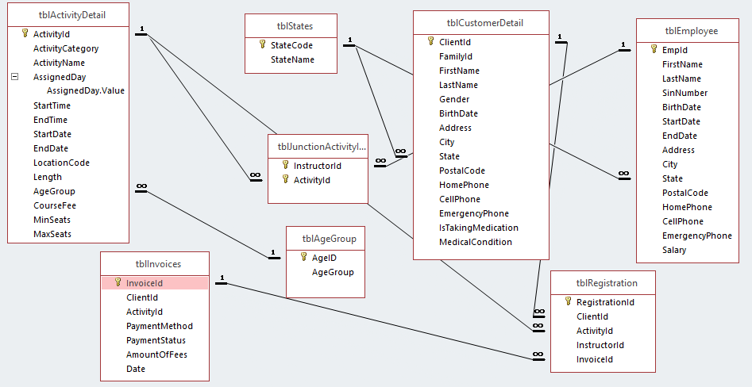

**Table Screenshots:**

**tblCustomer:**

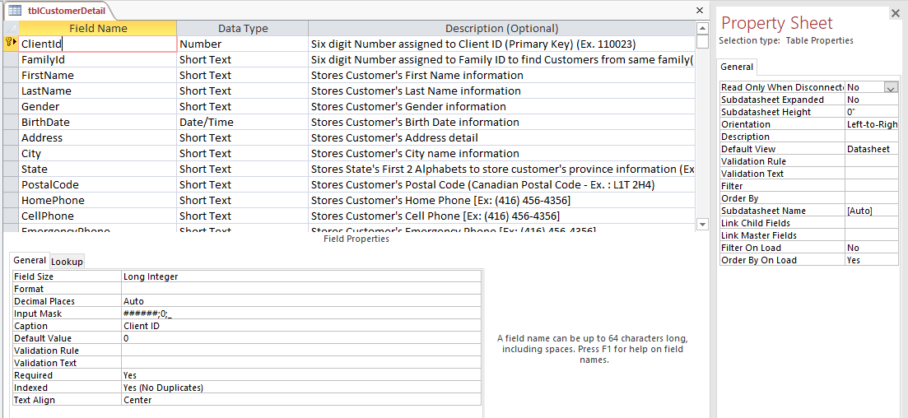

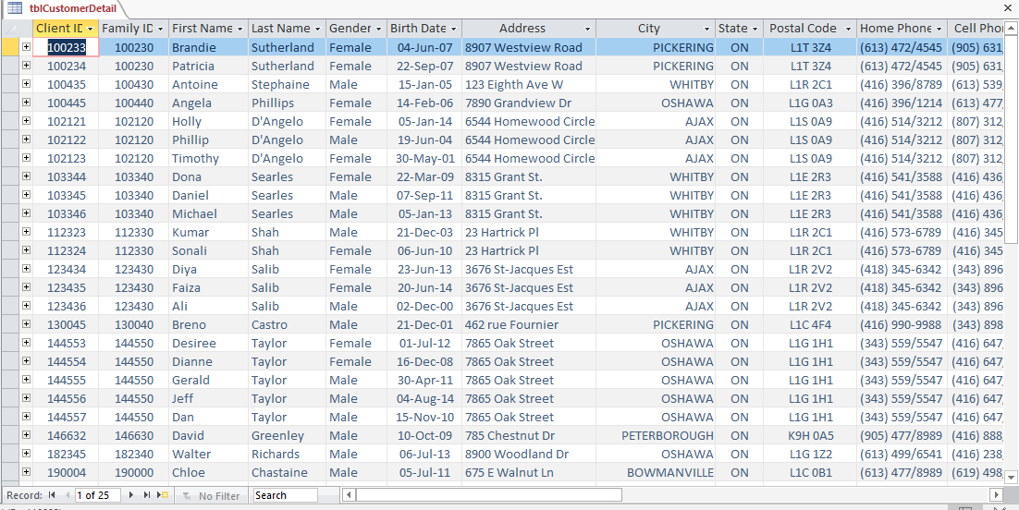

**tblActivityDetail:**

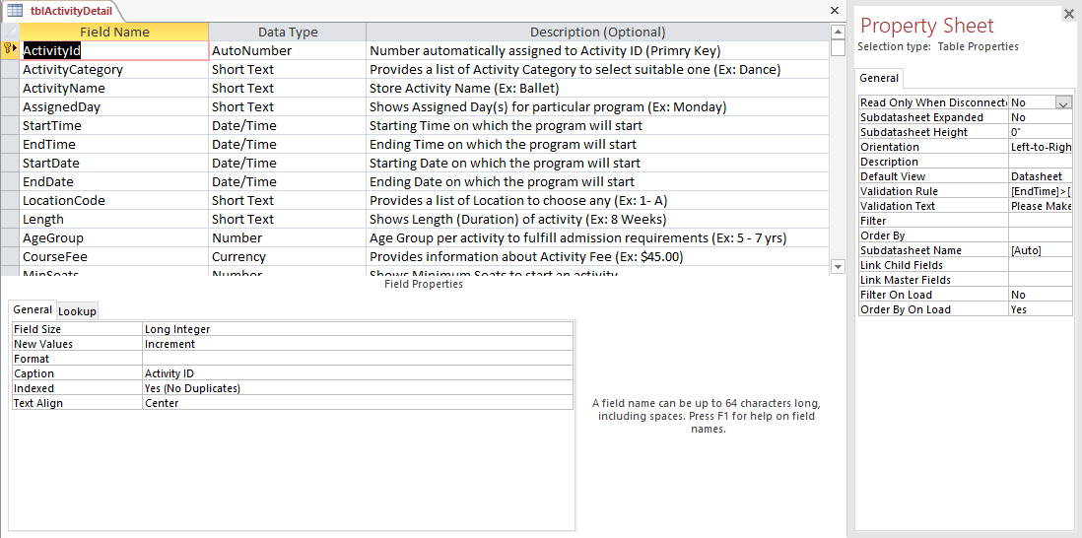

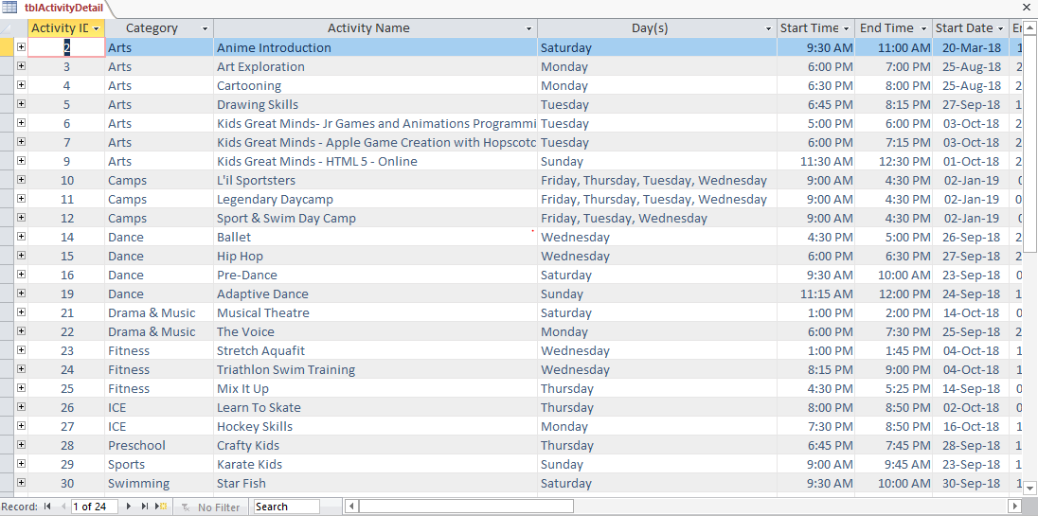

**tblEmployee:**

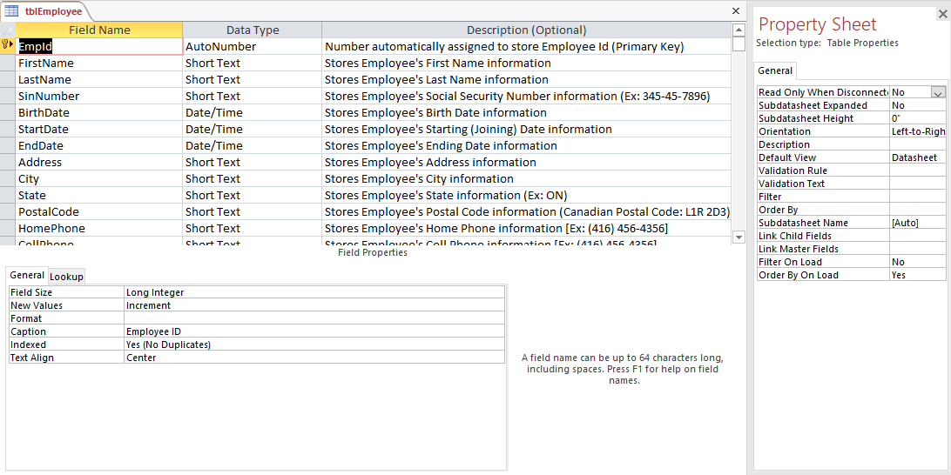

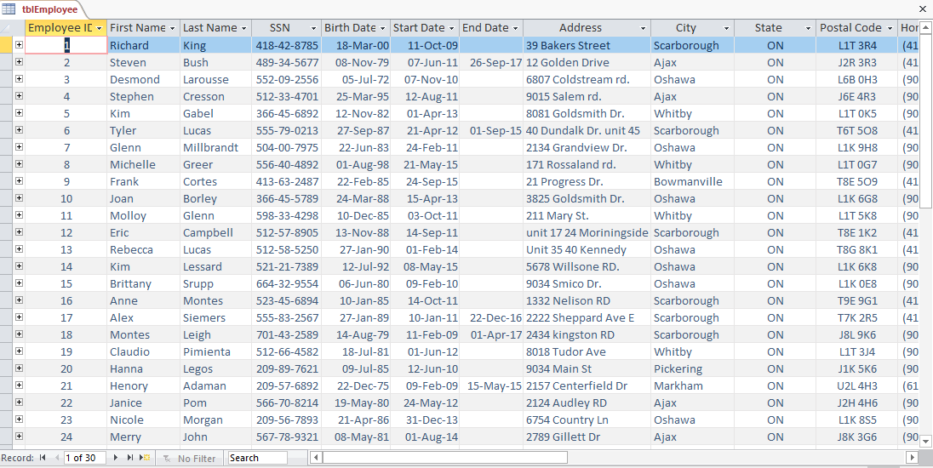

**tblAgeGroup:**

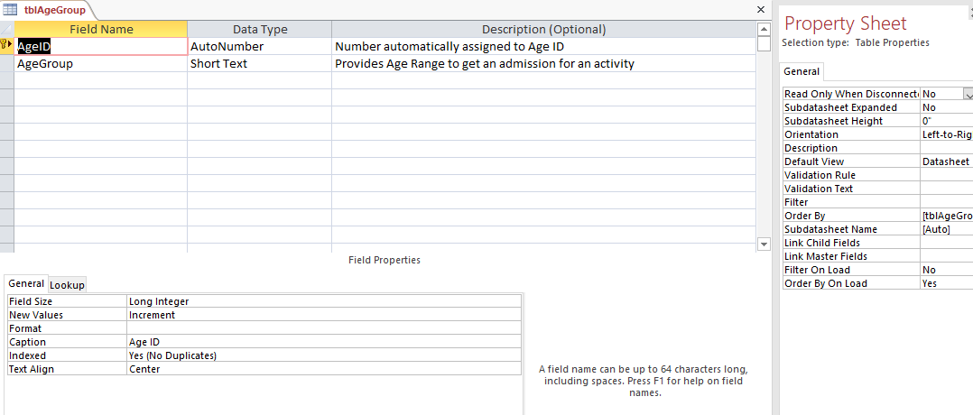

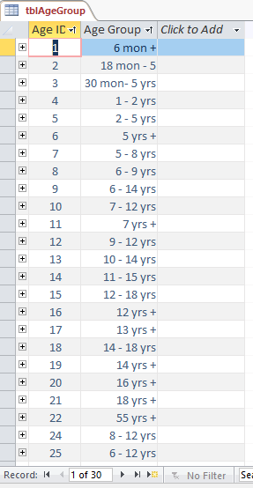

**tblInvoices:**

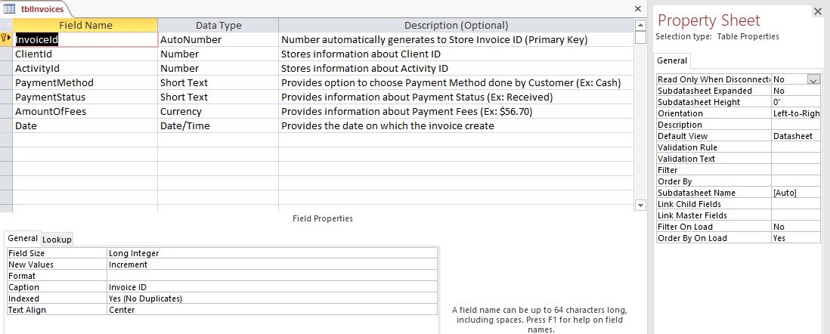

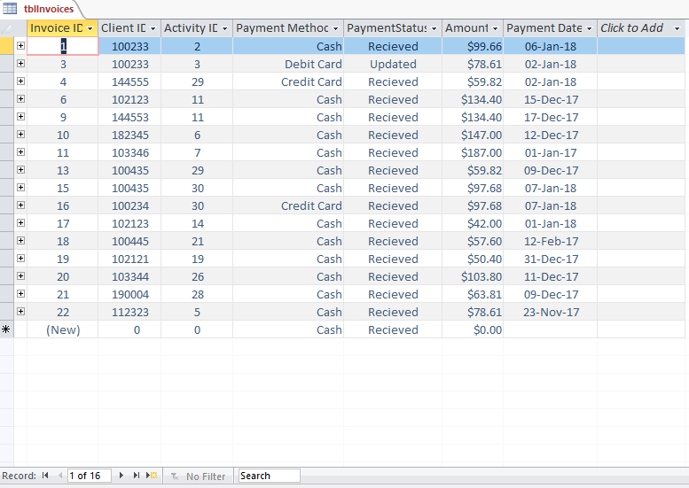

**tblJunctionActivityInstructor:**

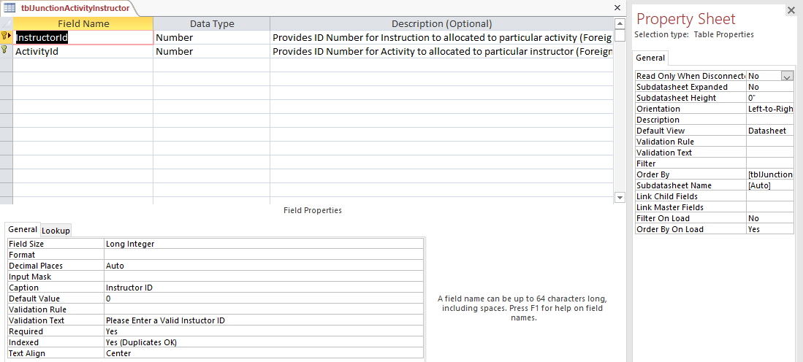

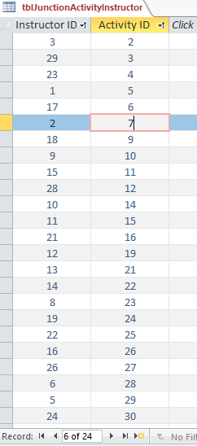

**tblRegistration:**

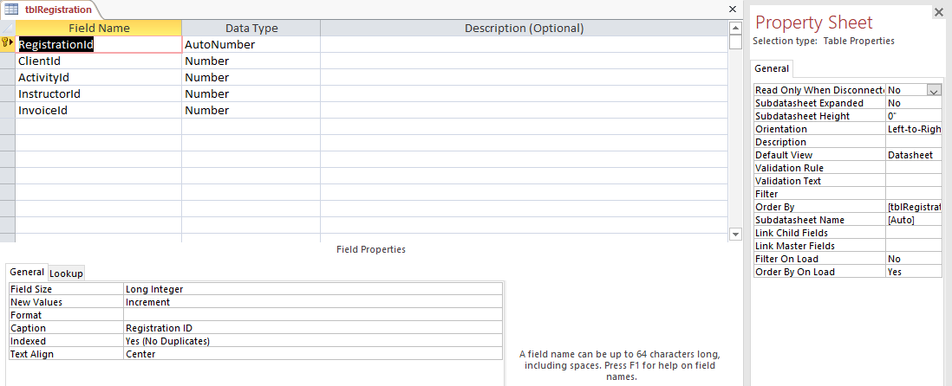

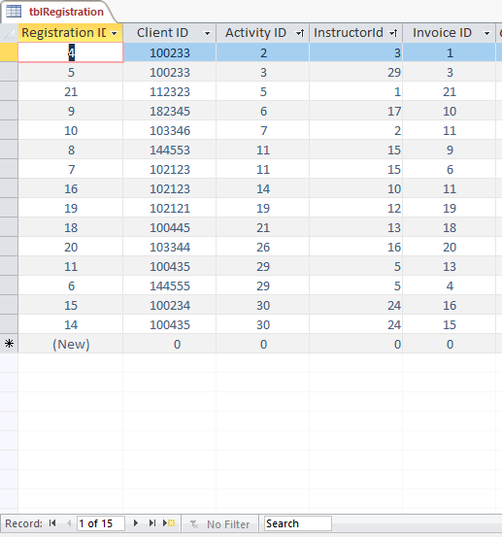

**tblStates:**

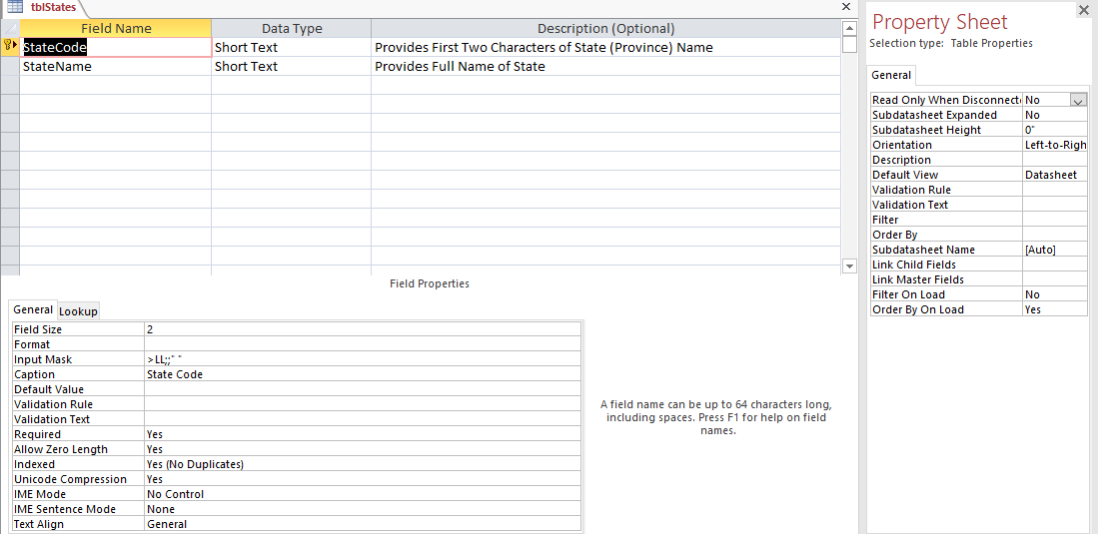

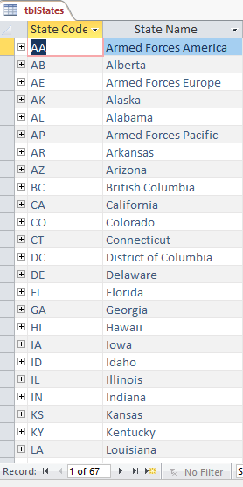

**Queries Screenshots:**

**qryClientRegistrationDetails:**

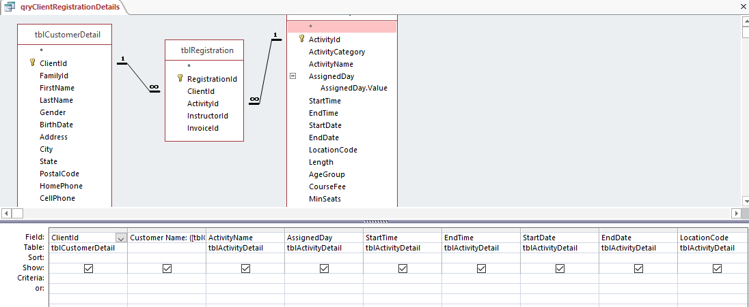

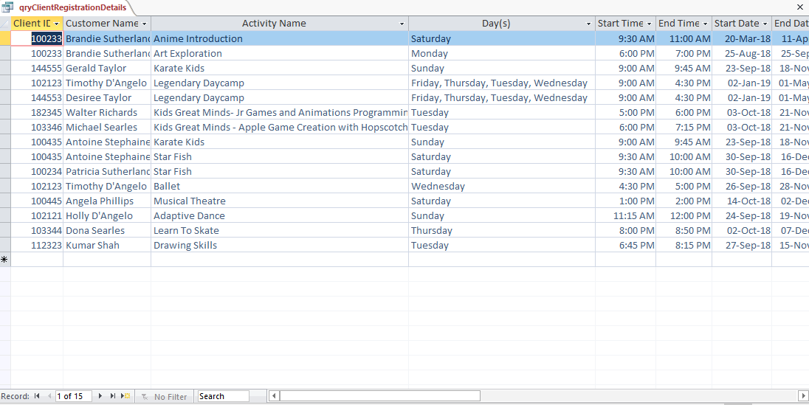

**qryCustomerAgeRequirement:**

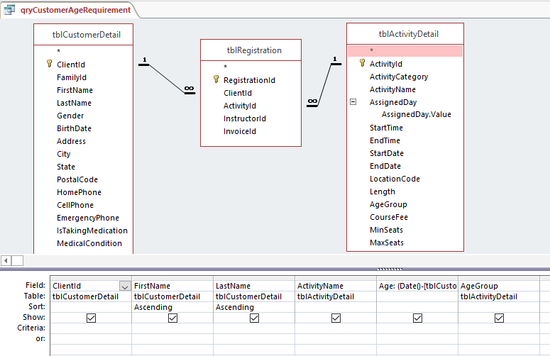

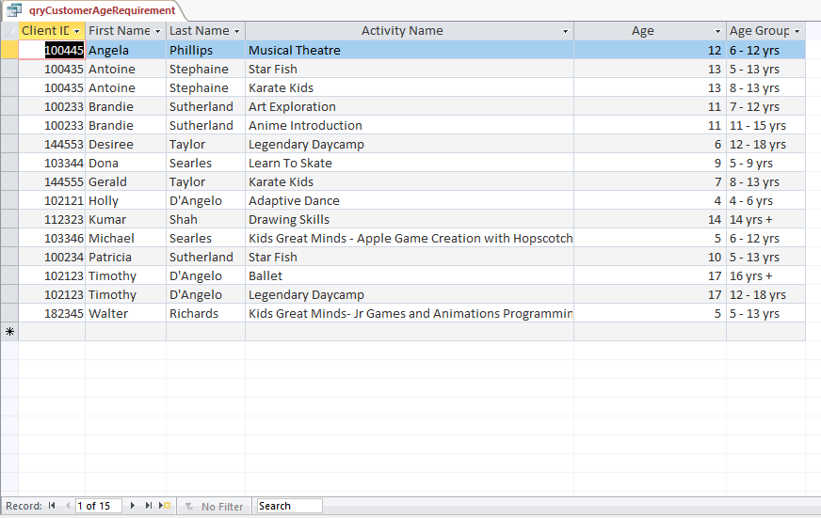

**qryFamilyIIDHouseAdresses:**

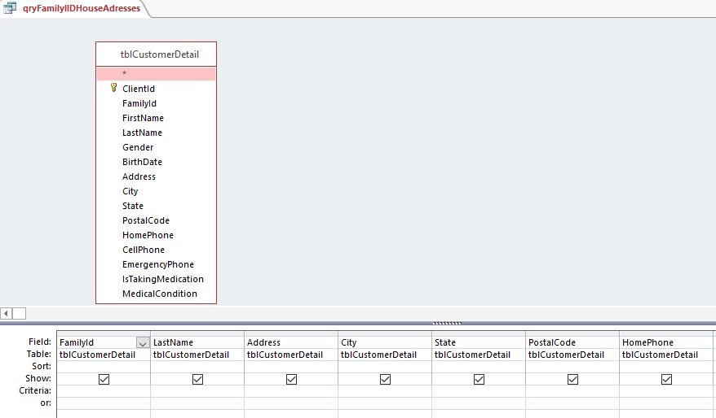

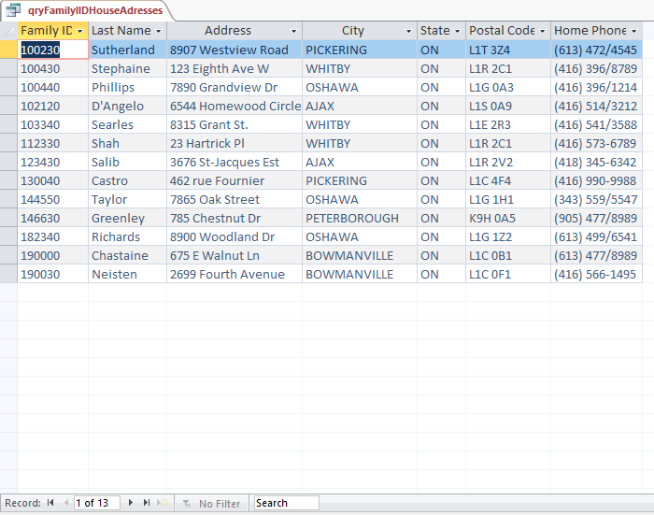

**qryFindEnrolledCategory:**

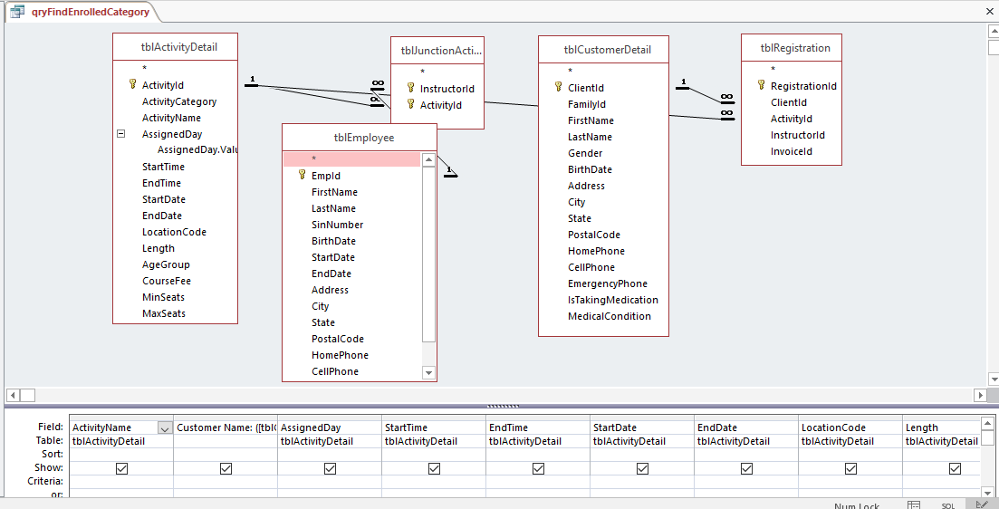

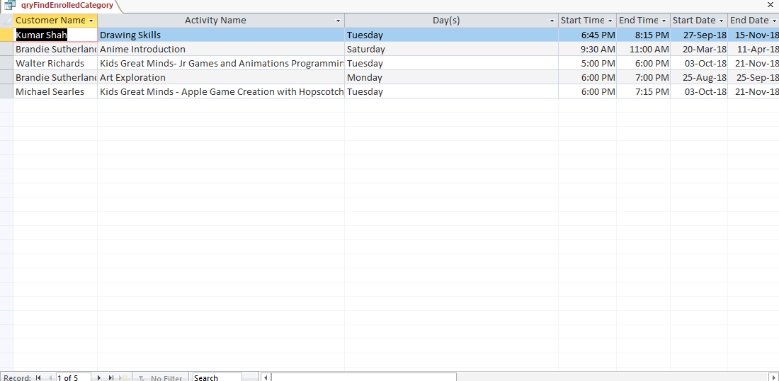

**qryIClientInformationPerFamilyId:**

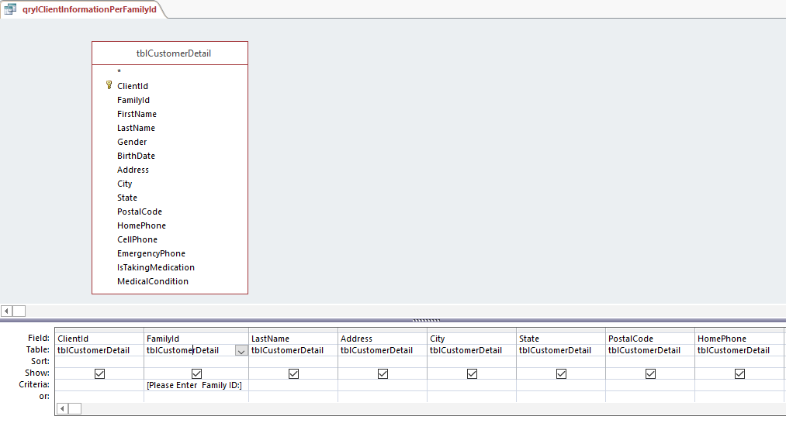

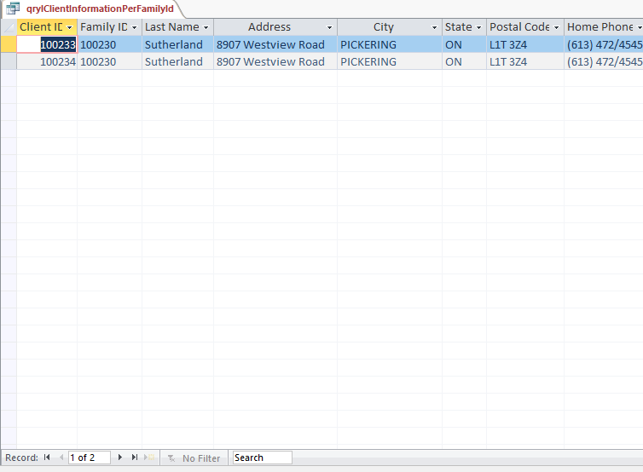

**qryOldCurrentEmployeesSalaryInfo:**

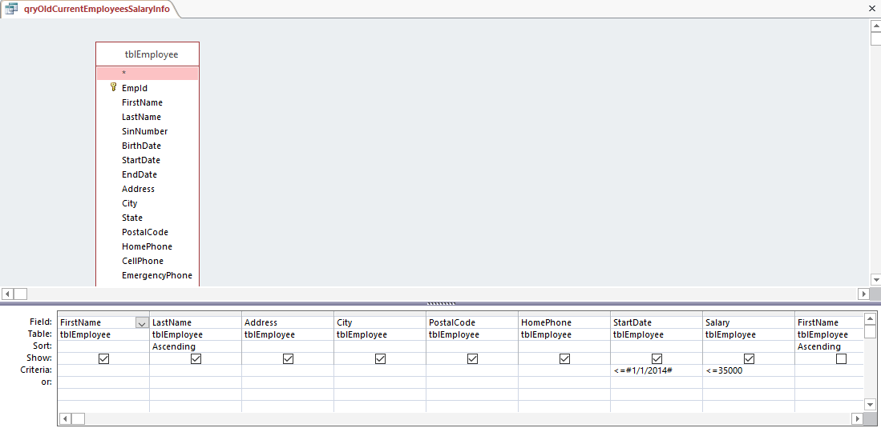

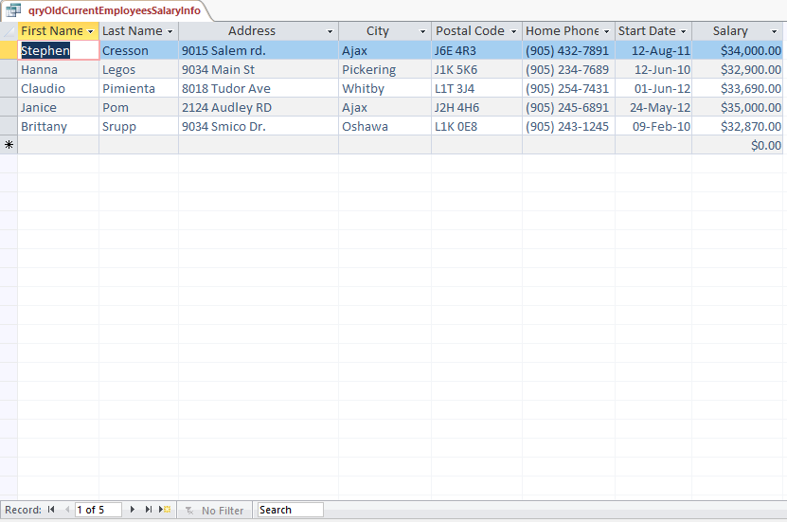

**qryTotalFeePerCategory:**

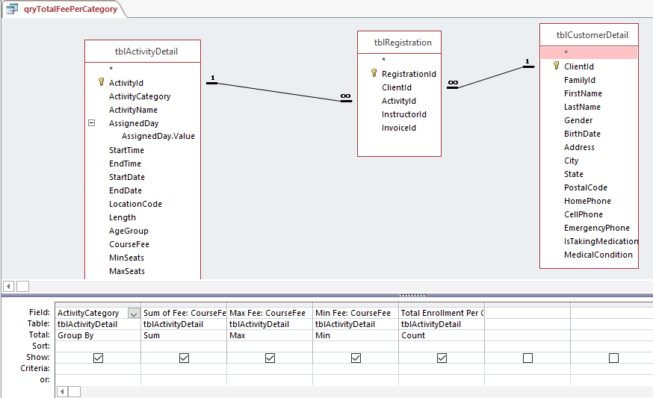

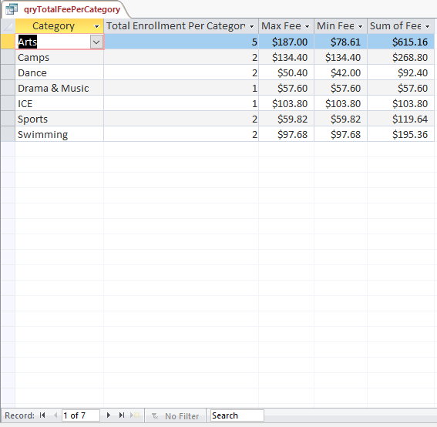

**Forms Screenshots:**

**frmActivityDetails:**

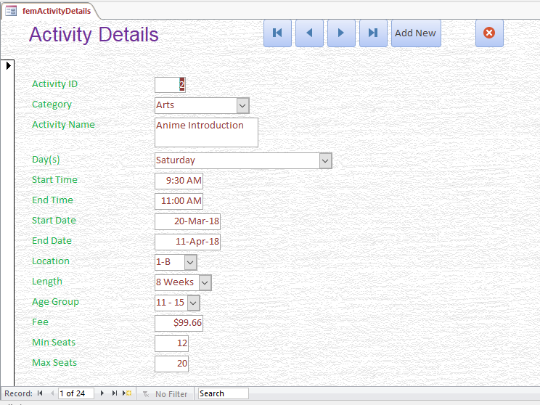

**frmEmployeeDetails:**

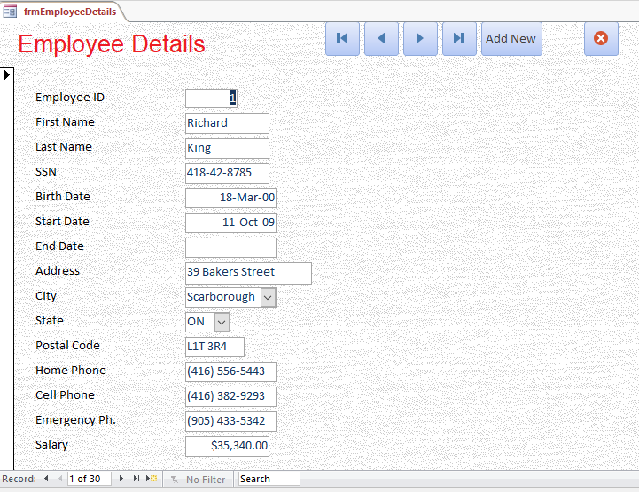

**frmCustomerDetails:**

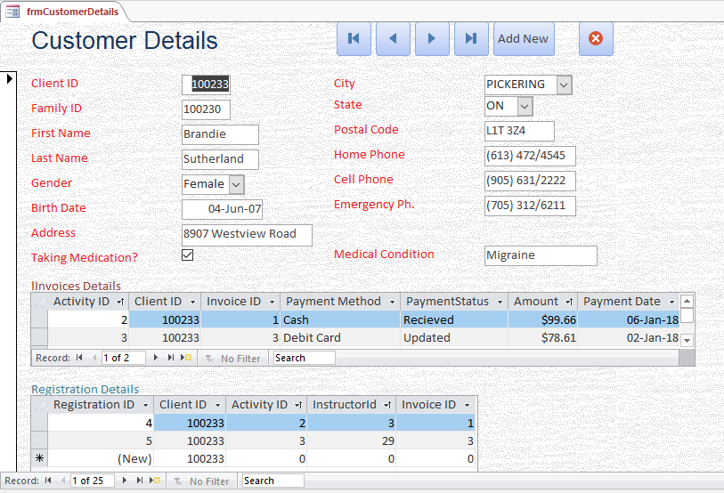

**frmnavRecreationDetails:**

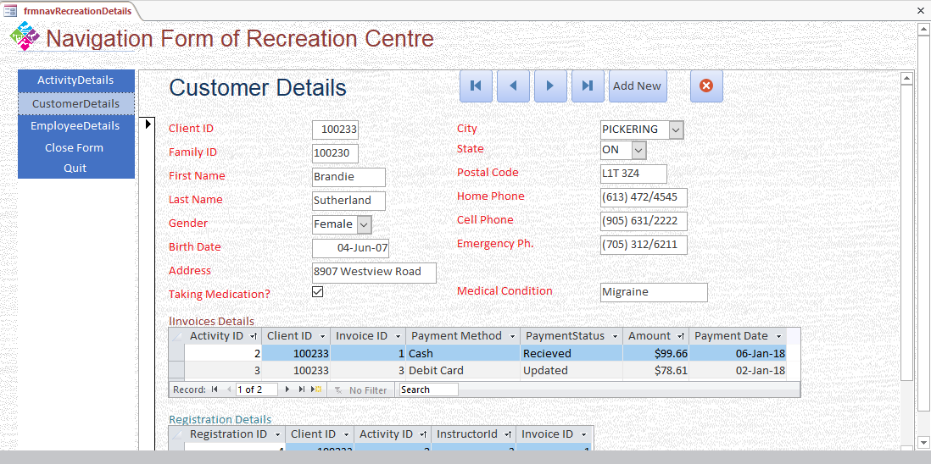

**Reports:**

**rptClientInformationFromFamilyId:**

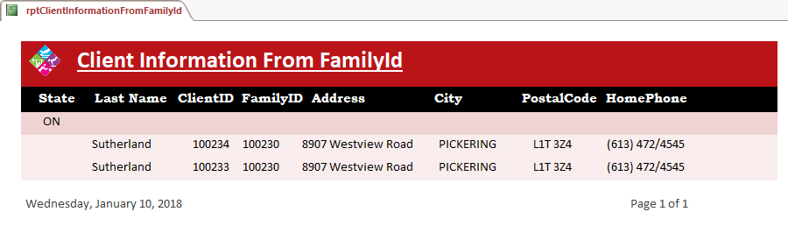

**rptCustomerEnrolledCategory:**

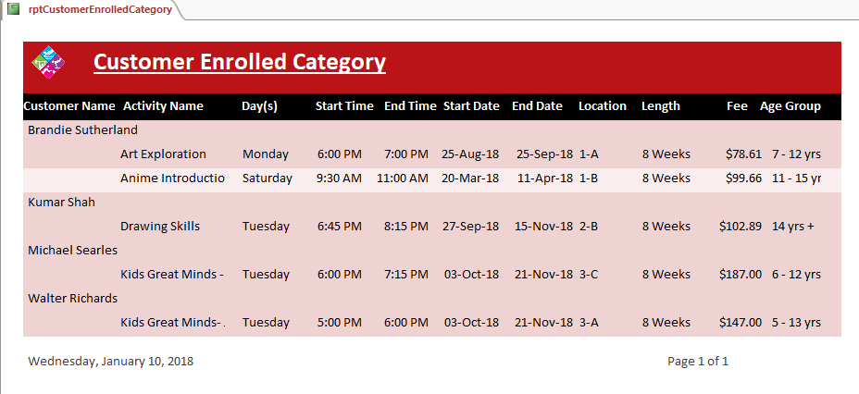

**rptTotalFeesPerCategory:**

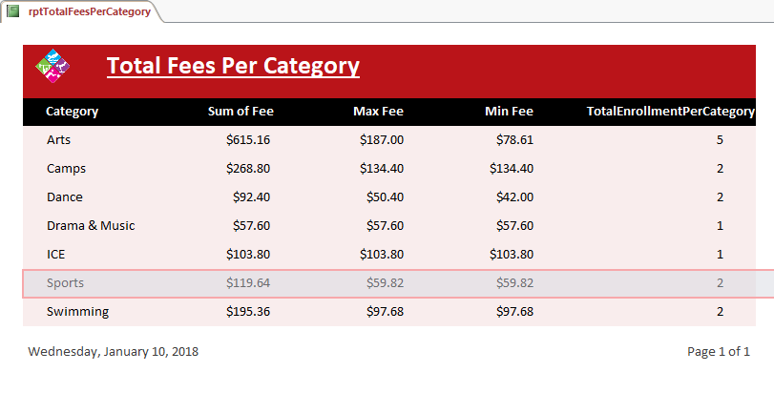

**rptRelationshipsMerryRecreationCentre:**

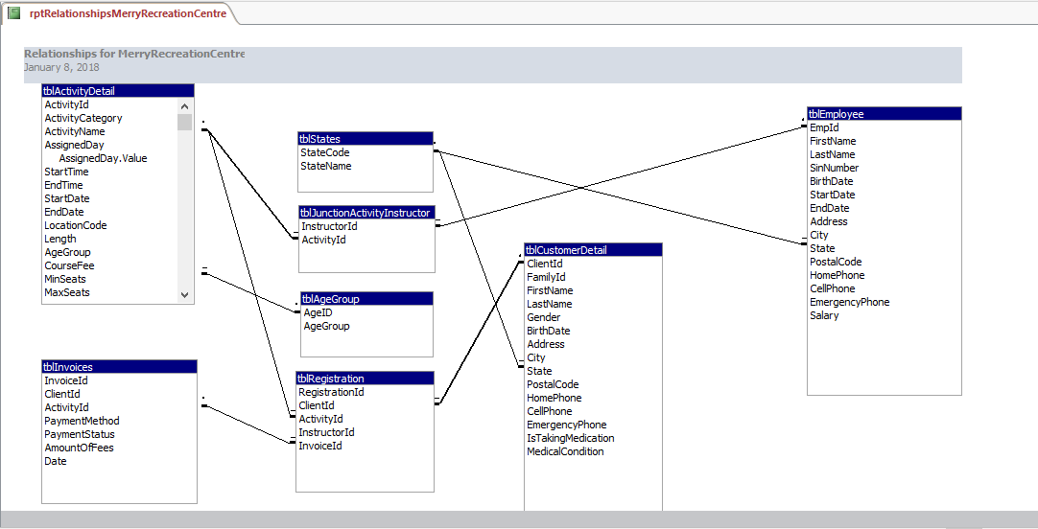

**Project Rubric**

|  |  |  |  |
| --- | --- | --- | --- |
|  | | **Out Of** | **Achieved** |
| **BASIC REQUIREMENTS** | |  |  |
| 1. | Database contains at least 4 tables | **2** |  |
| 2. | Database contains at least 16 unique fields | **4** |  |
| 3. | Fields utilize a variety of data types (>4) | **2** |  |
| 4. | Each table has an appropriate Primary Key | **4** |  |
| **TABLE RELATIONSHIPS** | |  |  |
| 5. | Tables are related to at least one other table using appropriate Foreign Keys | **5** |  |
| **TABLE STRUCTURES** | |  |  |
| 6. | Field names match naming conventions | **1** |  |
| 7. | Field types and sizes are appropriate | **3** |  |
| 8. | Descriptions are present for most fields | **1** |  |
| 9. | At least 1 field is using OLE to store pictures | **1** |  |
| 10. | All fields are formatted appropriately | **2** |  |
| 11. | Input Mask utilized appropriately on at least 3 fields | **3** |  |
| 12. | Default values are set for at least 2 fields | **2** |  |
| 13. | All Foreign Keys are set up using the LookUp feature | **4** |  |
| 14. | Appropriate validation rule and text properties are set for at least 2 fields | **2** |  |
| 15. | 1 field other than Primary Key is set to ‘Required = Yes’ with description as to why | **1** |  |
| **SAMPLE DATA** | |  |  |
| 16. | At least 25 records are present across the whole database and provide enough information to see forms/reports functioning | **2** |  |
| **QUERIES** | |  |  |
| 17. | At least 5 uniquely configured and appropriate queries | **5** |  |
| 18. | At least 2 queries are using multiple tables as their sources | **2** |  |
| 19. | Most queries show appropriate and varied use of criteria | **3** |  |
| 20. | Queries show appropriate use of sorting | **2** |  |
| **FORMS** | |  |  |
| 21. | At least 3 uniquely configured custom forms are present | **3** |  |
| 22. | At least 1 adequately and sourced form | **1** |  |
| 23. | At least 1 adequately and sourced multi-form (using sub-form) | **1** |  |
| 24. | Development controls & object navigator are hidden from user | **1** |  |
| 25. | All custom objects are all accessible through navigation forms | **1** |  |
| 26. | Overall design is consistent (fonts, colours, logos, buttons, placements) | **1** |  |
| **REPORTS** | |  |  |
| 27. | At least 2 uniquely configured custom reports are present | **2** |  |
| 28. | At least 1 report uses multiple tables as a record source | **1** |  |
| 29. | Overall report design is consistent and user-friendly | **2** |  |
| 30. | All reports are adequately formatted for hard-copy printing | **1** |  |
| **USER MANUAL** | |  |  |
| 31. | Manual meets all requirements including formatting, spelling, grammar, and all requested screen shots of database objects. | **5** |  |
| 32. | Manual demonstrates obvious care and attention given to submitting a professionally formatted and presented report. | **5** |  |
| **TOTAL** | | **75** |  |

**APA Reference:**

**Durham College Logo:**

* URL**https://www.google.ca/search?hl=en-CA&q=durham%2Bcollege%2Bcanada%2Blogo&tbm=isch&tbs=simg%3ACAQSmQEJ6Fib4vSYyHEajQELEKjU2AQaBggVCAkICgwLELCMpwgaYgpgCAMSKIIK9gOyCIEKswexCIYD7wGYBoUDlz29KLM9mTeiPaE9tCi1PZY9sj0aMIs37g6NV6JbfTcMjekLAML90jDNLw9D0y7MyiPOfSofaKDHiURfEGZ9G43JQFs7JSAEDAsQjq7-CBoKCggIARIE18Fl7Qw&sa=X&ved=0ahUKEwiFu7_KsMvYAhUs3IMKHY6qBKUQwg4IJigA&biw=1366&bih=662**
* Website Title: **durham+college+canada+logo - Google Search**
* Date Accessed: **January 09, 2018**

**Logo:**

* URL**https://www.google.ca/search?sa=G&hl=en-CA&q=monterey%2Bsports%2Bcenter%2Blogo&tbm=isch&tbs=simg%3ACAQSlQEJbRjibZivH7saiQELEKjU2AQaAggVDAsQsIynCBpiCmAIAxIongqdCuIIwAPxBp8KugLGA6MKmwq-PbI9oTSYKaA0yjfAPZ00tD3FPRowzbIbonkDBsR87l9syFVaoRRRZHTcIMTReIMCduk_1NyMigGdNUPM7NeWfjlV56JjcIAQMCxCOrv4IGgoKCAgBEgT3OJXODA&ved=0ahUKEwjiuP2Ms8vYAhXB1IMKHX_qCacQwg4IJigA&biw=1366&bih=662**
* Website Title: **monterey+sports+center+logo - Google Search**
* Date Accessed: **January 09, 2018**

**Book:**

* Book Title**Succeeding in business with Microsoft Access 2013: a problem-solving approach**
* Book Publisher**Cengage Learning**
* Publication Year**2015**

**Project Website:**

* URL**http://www.oshawa.ca/things-to-do/recreation.asp**
* Website Title**City of Oshawa**
* Article Title**Recreation**
* Date Accessed**January 10, 2018**